Winter 2020

Pre-registration is recommended.
To reserve your place, email bronxgreenup@nybg.org or call 718.817.8026.
Space is limited for some events; priority will be given to members of our sites in the Bronx.

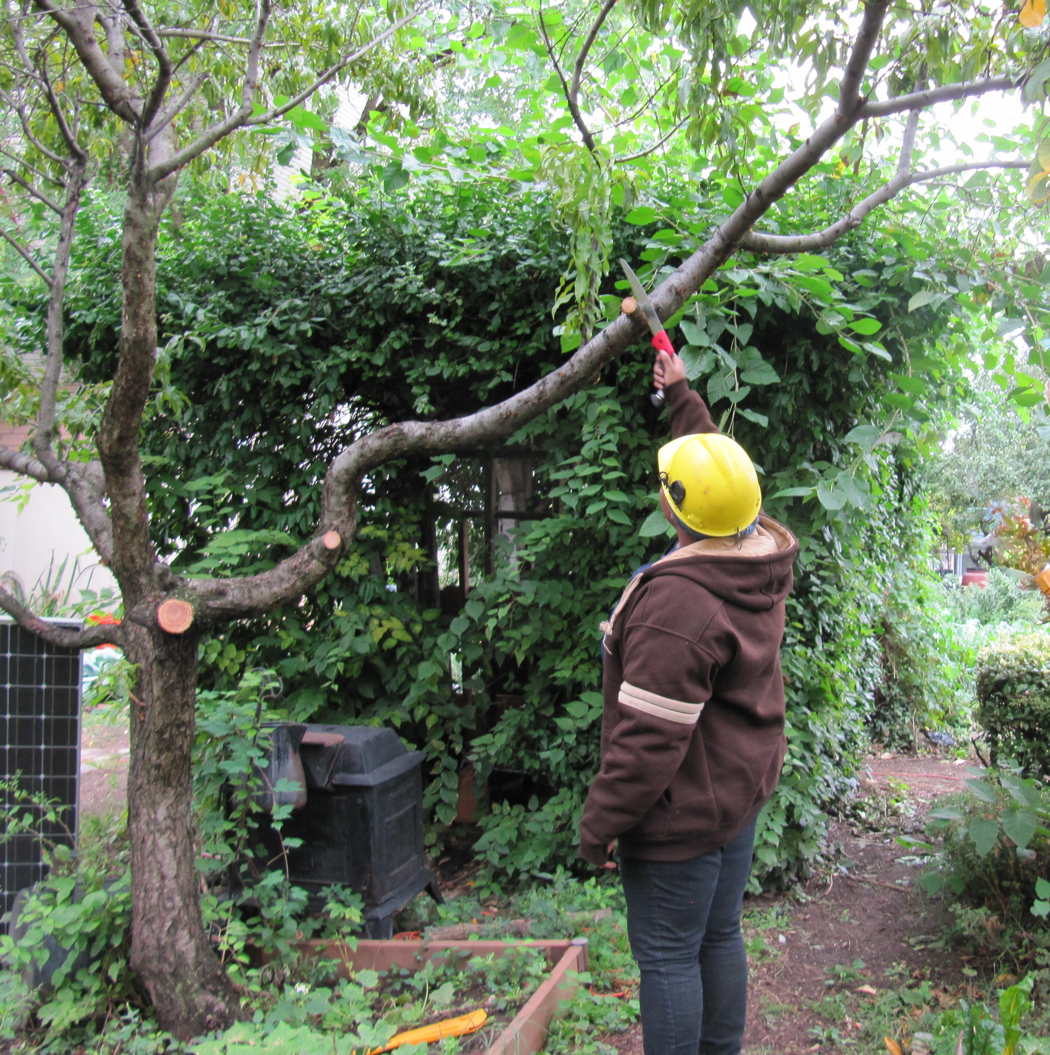
PRUNING CERTIFICATE SERIES
Applications due by January 6, 2020
Four Thursdays, January 30, February 6, 13, and 20 • 6–8 p.m.
The New York Botanical Garden • Watson Education Building

The Pruning Certificate course has been designed to help you learn how to prune properly and improve your community garden. This course is ideal for community gardeners who want to keep their gardens in good shape. The focus of the class will be on pruning small trees and shrubs, with a full class devoted to fruit tree pruning. To receive a pruning certificate you must attend the four classes listed below and demonstrate your pruning skills through 6 hours of practice at community garden workdays. Priority will be given to Bronx community gardeners, but others are welcome if space allows. For an application or more information, call 718.817.8026 or e-mail bronxgreenup@nybg.org

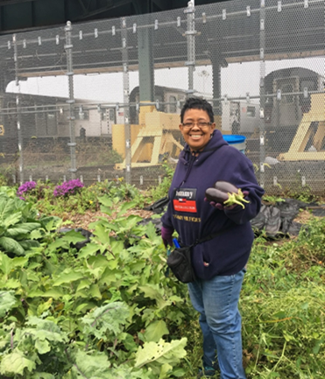
GROW MORE VEGETABLES CERTIFICATE SERIES
Applications due by February 18, 2020
Wednesdays, March 4, 11, 18, 25, April 1, and 8 • 6–8 p.m.
New York Botanical Garden • Watson Education Building

The Grow More Vegetables Certificate Series is an edible gardening course designed to equip community gardeners, teachers, and city residents with the best organic techniques for growing vegetables safely and effectively, particularly in an urban setting. The program consists of six classes, both in the classroom and with hands-on gardening instruction in the field. Each student will have the opportunity to design their own urban vegetable gardening project as a final component of the course. Priority will be given to Bronx community gardeners, but others are welcome if space allows. For more information, call 718.817.8026 or e-mail bronxgreenup@nybg.org. To apply, fill out an application here: https://tinyurl.com/BGUGrowmoreveggiesapp

STARTING SEEDS IN A GREENHOUSE OR INDOORS
Saturday, March 14 • 10 a.m.–1 p.m.
Praxis Warren Residence • 4339 White Plains Road

Get gardening early by starting your seeds in a greenhouse or sunny window. We’ll walk you through the steps of sowing, discuss what healthy seedlings need to grow into mature crops, and help you document the process by keeping good records. In partnership with NYC Parks GreenThumb, Praxis, and Urban Cultivated. Garden members who attend this workshop will be eligible for vegetable, flower, and herb seeds and seed starting kits. Registration required: To register, please email us at bronxgreenup@nybg.org or call us at 718.817.8026.

FRUIT TREE CARE WORKSHOP
Saturday, March 28 • 11 a.m.–1 p.m.
Jardin De La Roca • Elton Avenue & East 160th Street

Have you ever wondered about what you can do to get a great harvest from fruit trees in your garden? This workshop will cover the basics of maintaining healthy fruit trees year-round with an emphasis on the current spring season. We will cover best practices for maximizing fruit production. Participants will have an opportunity to get hands-on practice in assessing and caring for fruit trees in a community garden. In partnership with NYC Parks GreenThumb. Registration required: To register, please email us at bronxgreenup@nybg.org or call us at 718.817.8026.

RECEIVE E-NEWSLETTER OF BRONX GREEN-UP AND NYC COMPOST PROJECT

Want to stay in the know? Sign up for our newsletter, which is sent via e-mail. It will arrive before the first week of each month with news about opportunities for urban gardeners and composters, including workshops, events, resources, and job postings. If you would like to receive the e-newsletter, fill out this form at http://bit.ly/2kUFrIs.

