Lily of the Valley
Floral Design

Floral Internship Opportunity- Immediate
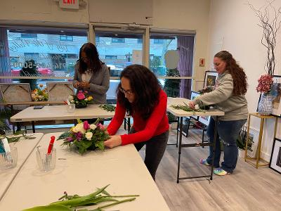

Responsibilities include: floral prep, preparing arrangements, shop maintenance, and event setup.

Schedule: Monday -Friday. On call for Saturday and events
Hours: flexible

Pay: stipend with potential for hire

Location
Lily of the Valley Floral Design
810 South Street
Peekskill, NY 10566
914-402-5000(Shop)
914-292-4211 (direct line)
Website: Lilyofthevalleyfd.com

Email: Lilyofthevalleyfd@outlook.com

